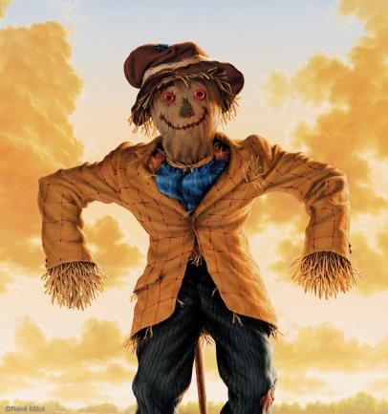
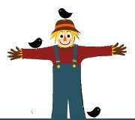
‘Sustainable Scarecrows’
Design Brief

Design and Technologies
Year 2

Background: You have been learning about how using re-usable and recyclable materials contributes to a more sustainable future.

Design Challenge: You will work in small groups (decided by your teacher) to design and create a scarecrow from re-usable/recyclable materials, to keep pests away from the school vegetable garden.

Criteria: Your scarecrow must be made from materials that:

- Are re-usable and recyclable, and contribute to a more sustainable future
- Can move (turn, twist, fly in the wind)
- Make noise or sound
- Are reflective or shiny

Materials: What materials can you use? Some suggestions are:

- Jar lids | - Milk bottles
- Cans | - Old CD disks
- Alfoil | - Old Fabric
- Straw/hay | - Old clothes – shirts, pants, overalls, hats, scarves, shoes, belts etc.
- Old cutlery | - Pillow cases
- Garbage bags/plastic bags | - Hessian bags
- Duct tape | - Baling twine
- Wood | - Nails
- Old broom | - Safety pins

Tools: What tools can you use? Some suggestions are:

- Hammer
- Scissors
- Hot glue gun
- Stapler
