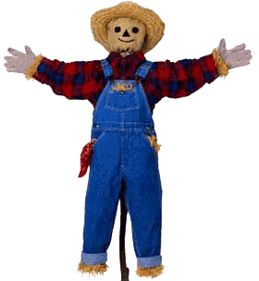
Name: ___________________________________________

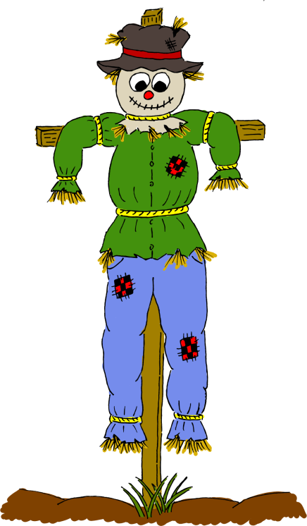
Sustainable
Scarecrows

Group members: _______________________________________________________________________
What is the Problem or the Need?

What problem or need has led you to
design and build a scarecrow?

State the problem or need in your own words below:
__________________________________________________________________________________________________________________________________________________________________________________________________________________________________________________________________________________________________________________________________________________________________________________________________________________________________________________________________________________________________________________________________________
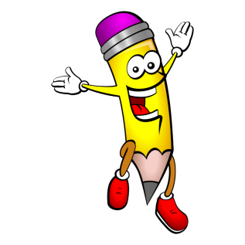
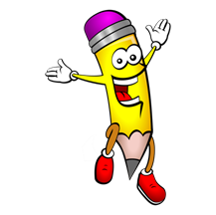
Draw and Label Your Individual Design

I believe this is a good design for the need or problem because:
________________________________________________________________________________________________________________________________________________________________________________________________________________________________________________
Design Criteria for Success

List the top 10 design decisions and design choices that will ensure your group’s scarecrow is a success!
Think about the materials and equipment you will need.
Remember to think about re-usable and recyclable products.
TIP:
A good scarecrow will be made from materials that:
- Are re-usable and recyclable, and contribute to a more sustainable future
- Can move (turn, twist, fly in the wind)
- Make noise or sound
- Are reflective or shiny

1. __________________________________________________________________
2. __________________________________________________________________
3. __________________________________________________________________
4. __________________________________________________________________
5. __________________________________________________________________
6. __________________________________________________________________
7. __________________________________________________________________
8. __________________________________________________________________
9. __________________________________________________________________
10. ________________________________________________________________
Draw and Label Your Final Group Design

We believe this is the best design for the need or problem because:
________________________________________________________________________________________________________________________________________________________________________________________________________________________________________________
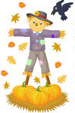
Materials and Tools Needed for Design

Materials
Tools

Justification of Materials and Tools

The materials were chosen for the final design because:

The tools/equipment were chosen for the final design because:

Sequence of Production Steps
Use the flow diagram below to show the sequence of steps your group will take to build your scarecrow. You can write and/or draw your steps.
1.
2.
4.
3.
5.
6.

Sequence of Production Steps Continued (if you need more)…

7.
8.
10.
9.
11.
12.

Evaluate Your Scarecrow
Was your group’s scarecrow successful in meeting the need or the problem? Observe your scarecrow and explain your group’s results.

Was your group’s scarecrow successful in meeting the need or the problem? Observe your scarecrow and explain your group’s results.

What design decisions and design choices were good about your design? How well did you follow your design criteria for success to produce your final product?
Was your group’s scarecrow successful in meeting the need or the problem? Observe your scarecrow and explain your group’s results.

What would you do differently if you were designing your scarecrow again and why?

